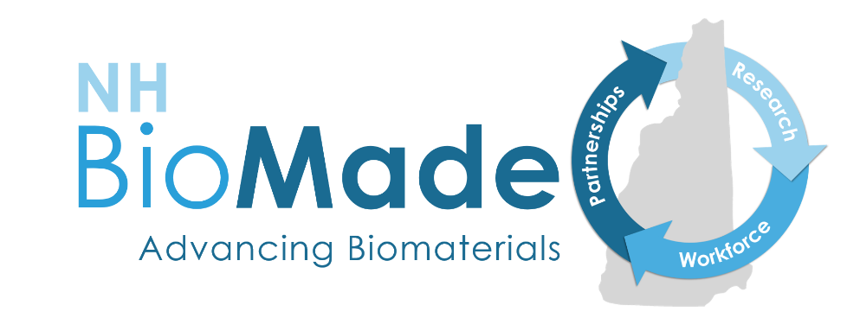
NH BioMade Education and Training Grant Opportunity:
Attracting, Training, and Retaining a Skilled Workforce

2022-23 REQUEST FOR PROPOSALS
APPLICATIONS ACCEPTED UNTIL JUNE 1, 2023
Questions? Email nh.epscor@unh.edu

Summary
This opportunity is for NH education professionals to develop and implement curriculum or training enhancements that will address skills gaps to better prepare students to enter a career or academic pathway in biomaterials or bio-related advanced manufacturing.
Eligible projects support secondary schools, career and technical education centers, community colleges, four-year colleges and universities, and informal science programs. We expect to support up to 10 projects with budgets up to $20,000 each. Projects must provide evidence of the creation and implementation of education or training enhancement(s) to address the skills gap listed in this RFP. We welcome and encourage projects that aim to create or enhance remote learning activities.
- Proposals are accepted and reviewed on a rolling basis until June 1, 2023
- Applicants must submit a Letter of Intent (LOI) to ensure the project is on the right track before developing a full proposal.
- Project budgets may be up to $20,000.

Purpose of this Grant Program
The purpose of this funding opportunity is to diversify the STEM workforce and to develop education or training enhancements to better prepare New Hampshire students to enter a career or academic pathway in biomaterials and bio-related advanced manufacturing.
Successful proposals will address the NH BioMade skills gaps (listed below) and result in measurable outcomes. Proposals should be designed to be inclusive of all learners, especially those students underrepresented in STEM disciplines.
Eligible projects will support NH secondary schools, career and technical education centers, community colleges, four-year colleges and universities, or informal science programs in developing and implementing curriculum and training enhancements that lead to inclusion of underrepresented groups in STEM industries and address the skills gaps summarized below.

Background
NH BioMade, a statewide initiative funded by the National Science Foundation, supports the rapidly growing New Hampshire biomaterials industry. Advances in biological research hold potential to save patient lives and improve overall quality of life. Biomaterials, such as those used in implants and tissue engineering, have stringent and potentially conflicting specifications (weight, strength, porosity, electrical conductivity, and complex geometries). NH BioMade advances the design and manufacture of biomaterials and develops the knowledge to predict and control their composition, structure, properties, and function. For more information visit www.nhepscor.org/nh-biomade.
NH BioMade’s workforce development program aims to attract, train, and retain a more diverse biomaterials and bio-related advanced manufacturing workforce by supporting students’ development of the knowledge and skills needed to contribute to this industry cluster. Skills gaps have been identified within core areas related to NH BioMade research: computational modeling, advanced manufacturing, biomaterials and bioprocessing as well as foundational work skills.

Skills gaps
Successful projects will address one or more of the skills gaps listed below. Projects supporting middle and high school students can address more foundational and basic skills gaps than post-secondary projects. Please note: This RFP does not prescribe which gaps are relevant to which grade level of students. It is up to the applicant to make the case for how the gap they choose will be addressed across multiple grades or within one grade.

Foundational work skills
- Career readiness
- Communication
- Critical/creative thinking
- Entrepreneurial thinking
- Problem solving
- Professional behavior
- Project management
- Team leadership

Computational thinking/modeling
- Logic models
- Simple programming
- Advanced programming
- Computational molecular bioengineering
- Compute Unified Device Architecture (CUDA) programming

Advanced manufacturing
- Hands on experience with:
  - Basic engineering processes/skills
  - Basic manufacturing processes/skills
  - Advanced manufacturing processes/skills
  - Biomanufacturing processes/skills
- Statistics
- 3D printing
- Mechanics in manufacturing
- Biomanufacturing control systems

Biomaterials
- Lab experience
- Mechanical behavior of biomaterials
- Advanced materials characterization
- Tissue engineering

Deliverables and outcomes
This RFP is intended to impact the education setting. Listed below are examples of types of deliverables this opportunity could fund; however, applicants may make the case for the value of other kinds of deliverables. Deliverables must address a skills gap listed above.
- Elective courses or course modules
- Adaptation of traditional in-person instructional materials for use in remote learning
- New industry-school partnerships or expansion of old partnerships
- Curricula to improve career awareness through experiential learning
- Evidence of increased direct interaction between learners and industry
- Curricular and extra-curricular activities focused on career pathways

Eligibility
Education or industry professionals within NH are eligible to apply. Questions? Email nh.epscor@unh.edu.

Funding
Applicants may request up to $20,000 per project. Projects focused on a single grade band (e.g., grades 6-8, grades 9-12, undergraduate, graduate) will generally need a smaller budget than those that span grade bands (e.g., collaborations to bridge transitions between educational levels). Projects must be completed in one year unless a longer period is approved.

Budget
Funds may be requested for materials or supplies, travel, salaries or wages, fringe benefits, and/or other expenses, not to exceed $20,000 in direct costs. Use the budget template and provide specifics for each item. Budgets must comply with federal guidelines for allowable costs expensed to grants. For example: meals, refreshments, gift cards, incentives, awards and clothing are not allowable costs.
Funds to cover indirect costs will be provided in addition to the $20,000 maximum direct cost amount. With the exception of UNH, Dartmouth, or Keene State, a copy of the academic institution’s current negotiated rate agreement with the federal government must be uploaded with the proposal. UNH, Dartmouth, and Keene State must apply the indirect rate in effect in August 2017. Public schools and districts do not need to provide documentation of indirect costs.
Questions? Email nh.epscor@unh.edu.

Application Process
- Applications for 2022-2023 will be accepted until June 1, 2023.
- All applicants must submit a Letter of Intent (LOI) as a first step (see below). Full proposal submission is by invitation only.
- Applicants whose LOI fits the scope and intention of this RFP will either be invited to submit a full proposal or to revise their idea and submit a full proposal. NH BioMade will share feedback with the intention to save submitter’s time from submitting full proposals that are out of scope.
- LOIs that do not include all the required information will be returned without review.
- Email all LOI documents in PDF format to nh.epscor@unh.edu
- Final proposal submissions should be routed as follows:
  - UNH Durham, UNH Manchester, and Keene State faculty projects submit final applications to Dianne Hall (SPA) at dianne.hall@unh.edu for sponsored programs’ institutional approval. Please cc: jennifer.baker@unh.edu
  - Other submissions from institutions of higher education outside of USNH, submit final applications with their institutional approval to nh.epscor@unh.edu
  - K-12 schools invited to submit a full proposal should email it to nh.epscor@unh.edu
- All applicants will be notified of the outcome of the review process within one month of receipt.
- Earliest start date: November 1, 2022

Review Process
A panel of reviewers including representatives from secondary education, colleges and universities, and industry will evaluate all letters of intent and full proposals. Successful projects will address the NH BioMade skills gaps and will result in measurable outcomes. Projects should be designed to be inclusive of all learners, especially those students underrepresented in STEM disciplines and include plans to reach them.
The following groups are considered underrepresented in STEM fields:
- Women
- Persons with disabilities
- Four racial and ethnic groups
  - Black or African American
  - Hispanic or Latino
  - American Indian or Alaska Native
  - Pacific Islander
- Veterans
- LGBQTA
- Low socio-economic status (proportion of students receiving free and reduced lunch, financial aid metrics)
- First generation college attendee (neither parent has completed a 4-yr degree).

The following criteria will be used in the review of LOI and full proposals:
- To what extent does the proposed project better prepare New Hampshire students to enter a career or academic pathway in biomaterials and/or advanced manufacturing?
- Does the project effectively address one or more skills gaps identified in the request for proposals?
- To what extent is the plan for carrying out the proposed activities well-reasoned, well-organized, and based on a sound rationale?
- How will the project include all learners?
- How effective is the evaluation strategy?
- How well qualified is the individual, team, or organization to conduct the proposed activities?
- Is the project likely to be completed in the time allowed?
- To what extent does the proposed budget adequately support the proposed activities?

Award conditions
Projects selected for funding will be required to:
- Sign a memorandum of understanding for terms and conditions
- Submit reports (a template will be provided)
- Quarterly progress reports
- Final project report within 30 days of completion
- Participate in NH BioMade evaluation and assessment activities such as a survey or interview
- Present the results of the project at a conference or symposium as a poster or oral presentation. NH BioMade staff is available to assist with this.

Required information
This RFP requires an initial Letter Of Intent (guidance below). NH BioMade will review all LOIs and select a subset of applicants to interview to get clarity on the project’s intent and deliverables. Applicants will be notified if they are invited to submit a full proposal or if their LOI was declined.
Format for all documents: 1-inch margins, 12-point font, single spaced.

LETTER OF INTENT
Letters of intent that do not include all required information will not be reviewed. Page limit: Cover page plus two pages. A detailed budget is not required for LOI.

Cover Page
- Project title
- Budget requested
- Applicant’s name, position or title, institution or school, email address, telephone, mail address.
- Anticipated start date and completion date (one year unless specifically approved for more).
- Collaborator(s) name, position or title, institution or school

Project Description (2 pages maximum)
Briefly and at a high level, describe the project by addressing the following questions:
- What is the overarching goal of the project and how does it address the skills gaps listed in this RFP?
- What are the specific objectives and deliverables?
- What level(s) of learner(s) will participate in the project or benefit?
- How will most of the budget be used?

FULL PROPOSAL
By invitation only. Page limit: Six pages.

Project Description
- Project title
- Project description (up to 6 pages). Describe your concept for this curriculum and training enhancement project by addressing the following questions:
  - What are the project objectives, deliverables and associated tasks?
  - Which skills gap(s) does the project address?
  - How will the deliverables be made inclusive of all learners especially those students underrepresented in STEM disciplines within your student population. (NSF definition here)
  - How will the project be evaluated and what are the qualitative and/or quantitative metrics/indicators you will collect and analyze?
- Roles and responsibilities: Include a brief statement (less than a half page) for each person describing their role on the project and their qualifications for filling that role.
- How will project collaborators interact, share information, manage students, and make decisions throughout the project?
- Project timeline: please provide a timeline with milestones

Budget
- Fill out the budget template provided. Questions? Email nh.epscor@unh.edu.

CV/Resume
- Include a CV or resume (2-page limit) for applicant and all collaborators

NH BioMade is supported by an EPSCoR Research Infrastructure Improvement award (#1757371) from the National Science Foundation. The program is administered by the NH EPSCoR state office at the University of New Hampshire. For more information, visit www.nhepscor.org

