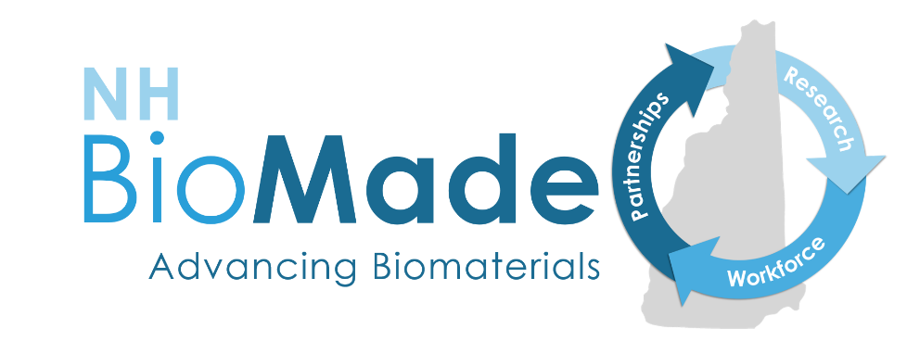

# **NH BioMade Research Seed Funding Opportunity 2022**

# **OVERVIEW OF SEED FUNDING SOLICITATIONS**

# **REQUEST FOR PROPOSALS**

**Revised November 1, 2021**

**EMERGING AREA PILOTS: EMAIL INTENT TO APPLY BY JANUARY 4, 2022.**

**PROPOSAL SUBMISSION DEADLINE: JANUARY 18, 2022**

**INDUSTRY COLLABORATIONS AND CORE FACILITIES APPLICATIONS ACCEPTED THROUGHOUT YEAR**

## **PURPOSE**

The purpose of the NH BioMade Research Seed Funding Opportunity is to expand research capacity at the state’s academic institutions by providing support for faculty and post-doctoral associates at universities, four-year colleges, or community colleges to pursue research questions **related to** the NH BioMade focus areas but the topic does not have to adhere to NH BioMade’s four research thrusts. Also, New Hampshire companies may collaborate with academic researchers on a research project and/or apply for use of core facilities through these seed funding opportunities. A separate RFP is issued annually for education and workforce development projects.

## **SYNOPSIS OF OPPORTUNITY**

There are three opportunities for research seed funding. For complete information and application packets, go to link below for each opportunity.

* Emerging Area Pilot: Support for projects that address an identified technical gap or expand the NH BioMade research portfolio in exciting new directions. High-risk, high-reward research that could transform biomaterial design and manufacturing and projects involving new faculty hired in support of NH BioMade will be prioritized. (Up to $50,000 a year per award; 3, 1-year projects anticipated each year.) Details: <https://www.nhepscor.org/emerging-area-pilot-seed-funding-opportunity>
* Industry-University Collaboration: Support for projects that promote translation of NH BioMade research or address an identified technical gap through a partnership with industry. Projects must align with NH BioMade goals and involve teams composed of university and industry participants. No funds can be provided to the industrial partner, only the university collaborator. Projects that support NH industry needs or leverage Advanced Regenerative Manufacturing Institute (ARMI) funding and/or partnerships will be prioritized. NH BioMade will also consider co-funding opportunities provided by the NH Innovation Research Center (a statewide program funded by the state of NH) that are targeted at early stage and/or innovation companies partnering with university researchers. (Up to $50,000 a year per award; 3, 1-year projects anticipated each year.) *INDUSTRY-UNIVERSITY COLLABORATION APPLICATIONS ARE ACCEPTED THROUGHOUT THE YEAR.* Details: <https://www.nhepscor.org/industry-university-collaboration-seed-funding-opportunity>
* Utilizing NH BioMade Core Facilities: Support for projects that drive NH and regional academic and industry partners to utilize NH BioMade computational modeling, advanced manufacturing, and materials characterization core facility with possible outreach to primarily undergraduate institutions and community colleges. Funds can be used to support direct or remote access to the facilities, technical support, or consultation related to instrumentation, high performance computing (HPC), including multi-scale modeling software/coding resources, and advanced manufacturing. Email Shawn Banker, Director, University Instrumentation Center, for information on rates and use of instruments, [shawn.banker@unh.edu](mailto:shawn.banker@unh.edu), or Robert Anderson of the Research Computing Center, for information on the use of the HPC cluster, [robert.e.anderson@unh.edu](mailto:robert.e.anderson@unh.edu). (Up to $5,000 per award; 5 projects anticipated each year.) *CORE FACILITIES APPLICATIONS ARE ACCEPTED THROUGHOUT THE YEAR.* Details: <https://www.nhepscor.org/utilizing-core-facilities-seed-funding-opportunity>

### **Eligibility**

See specific solicitation for eligibility information.

### **Limit on number of proposals**

An academic investigator may collaborate on any of the solicitations but can be the lead on only one proposal per opportunity. Industry personnel can be the lead only on a proposal for Utilizing Core Facilities but may be a collaborator on other proposals. Funds are distributed only to academic institutions.

### **Due date**

Emerging Area Pilots: Email intent to apply by January 4, 2022. Application submission deadline is January 18, 2022. Awards will be announced in February 2022.

Industry-University Collaborations and Utilizing Core Facilities applications are accepted throughout the year. Intent to apply is not required.

### **Availability of funds**

This funding opportunity is supported by an EPSCoR Research Infrastructure Improvement Track-1 award. Availability of funds is contingent upon continued funding by the National Science Foundation.

### **Intellectual property rights**

For the Industry-University Collaboration solicitation, academic and industry partners should agree in advance as to how intellectual property (IP) rights will be handled. A signed university-industry agreement on IP (including publication and patent rights) must be submitted prior to issuance of the award for research projects. The IP agreement must be drawn up by the applicant’s institution, signed by the industry-designated official, and approved by the University of New Hampshire Sponsored Programs Administration. A draft IP agreement is included in the application packet. Any proprietary or privileged information should be marked as such in the proposal.

### **Contacts:**

Michelle Gregoire, Program Manager, NH EPSCoR: [michelle.gregoire@unh.edu](mailto:michelle.gregoire@unh.edu)

Susan Higgins, Business Manager, NH EPSCoR: [susan.higgins@unh.edu](mailto:susan.higgins@unh.edu)

Brad Kinsey, NH BioMade PI: [brad.kinsey@unh.edu](mailto:brad.kinsey@unh.edu)

## **REQUIRED INFORMATION**

Format: Follow [NSF guidelines](https://www.nsf.gov/pubs/policydocs/pappg20_1/pappg_2.jsp) for proposal preparation.

Proposals that do not include all the required information will be returned without review.

Email all documents in one zipped file to [susan.higgins@unh.edu](mailto:susan.higgins@unh.edu).

## **REVIEW CRITERIA**

The NH BioMade Project Management Team (and other designees) will review applications following standard [NSF review criteria for Intellectual Merit and Broader Impacts](https://www.nsf.gov/pubs/policydocs/pappg20_1/pappg_3.jsp), with additional emphasis on innovation, advancement of NH BioMade goals, support of early-career and underrepresented faculty, and sustainability.

## **AWARD CONDITIONS**

See specific solicitation for award conditions.

## **OVERVIEW OF NH BIOMADE**

Advancements in health care are revolutionizing medicine. The number of knee replacements tripled between 1992-2011, and the prospect of manufacturing replacement organs is progressing towards a reality. These life-changing advances will be further accelerated and improved by innovations in biomaterials and biomanufacturing.

The structure and function of natural biological systems are characterized by complex hierarchical relationships in scale and heterogeneity in space. Biomaterials have stringent and at times conflicting specifications (biocompatibility, weight, chemical resistance, electrical conductivity requirements, and complex geometries) that limit the development of more advanced biomaterials. The underlying biological structures of human joints, for example, have tremendous heterogeneity in composition and spatial-specific properties. As such, replacement materials are required to have differential, heterogeneous requirements for strength, wear-resistance, and porosity.

Biomaterials also have hierarchical relationships (composition, structure, properties, and function) that vary across scales. Scaffolds to support tissue regrowth require nanostructured morphology for optimal cell recognition, adhesion, and migration, alongside requirements at larger scales related to strength, composition, and biodegradability. Similarly, the biocompatibility (surface wettability, charge, and roughness) and mechanical behavior of metals are governed by atomic characteristics that hierarchically propagate from the polycrystalline scale to the product level.

Specific knowledge and skills gaps related to the design and manufacture of new hierarchical, heterogeneous biomaterials include:

* Current computational models do not span the required spatial and temporal scales that enable rapid experimentation to predict scale-dependent hierarchy and biomaterial heterogeneity.
* Available manufacturing approaches do not combine bottom-up and top-down methods to purposefully structure biomaterials down to nanoscale phenomena.
* Conventional trial-and-error approaches do not advance a systems-level approach (using an iterative make/model/measure paradigm), which is required to: (a) integrate multidisciplinary knowledge with multiscale tools and thinking across computational, fabrication, and characterization domains; and (b) drive heterogeneous biomaterials design and manufacture for highly specific functionality.
* The existing STEM workforce lacks diversity, and current educational models do not provide the broad interdisciplinary training in computational modeling, data visualization, materials science, and advanced manufacturing techniques to prepare next-generation workers to predict, validate, engineer, and deploy new advanced biomaterials for diverse technological applications.

NH EPSCoR proposes to address these gaps by expanding (via new investments in human, cyber, and physical infrastructure) and integrating scientific assets and educational capacity to establish the New Hampshire Center for Multiscale Modeling and Manufacturing of Biomaterials (NH BioMade; Fig. 1).

***Figure 1****. NH BioMade structure and outcomes.*

### **NH BioMade Summary**

The New Hampshire Center for Multiscale Modeling and Manufacturing of Biomaterials (NH BioMade) is supported by the National Science Foundation EPSCoR Research Infrastructure Improvement Program ($20M/5-year, award #1757371). NH BioMade is led by Brad Kinsey, University of New Hampshire professor of mechanical engineering and materials science and director of the UNH Center for Advanced Materials and Manufacturing Innovation, with interdisciplinary research partners at UNH (John Tsavalas, Harish Vashisth, Erik Berda, Marko Knezevic, Kyong Jae Jeong, and Igor Tsukrov), Dartmouth College (Ian Baker, Doug Van Citters, Katherine Mirica, Weiyang Li, and Chenfeng Ke) and Keene State College (Lisa Hix and Md. Ahasan Habib), and the John Olson Advanced Manufacturing Center (John Roth). Education and workforce development partners include the Community College System of New Hampshire and Keene State College. Website: <https://www.nhepscor.org/nh-biomade>

### **NH BioMade Research Objectives**

NH BioMade advances the multiscale design and manufacture of hierarchical, heterogeneous metal and polymer biomaterials to predict and control composition, structure, properties, and function. The deliberate structuring of biomaterials from nanometer to continuum scale has the potential to significantly improve important material qualities and address interactions and trade-offs between conflicting requirements and properties. This goal is being achieved through four research thrusts that: 1) address gaps in current science and manufacturing capabilities, 2) expand intellectual capital via new targeted faculty hires, 3) build R&D capacity through new investments in cyber and physical infrastructure; and 4) educate and train a diverse workforce. The four research thrusts are the design and manufacture of hierarchical, heterogeneous: 1) composites for orthopedic bearings, 2) sheet metal for trauma fixation, 3) scaffolds for tissue regeneration, and 4) porous, conductive structures for biosensor applications (Table 1). The research thrusts include both metal and polymeric materials motivated by different applications in the biomaterials space; cross four computational modeling scales; and employ distinct bottom-up and top-down manufacturing processes.

***Table 1****. Science Traceability Matrix for the research program.*

