Individual Development Plan
Part 1: Complete the following individually. You don’t need to have answers to all of these questions right now. This is a living document that you can update over time and use to track research progress. You are encouraged to revisit your responses throughout your experience.
A. Reflect
Motivation: What inspires you about research in your chosen field? Are there any specific areas you hope to explore?

Skills and perspectives: As a product of your lived experiences, what strengths do you bring into the research setting?
You may wish to consider, but are not limited to:
- Any relevant coursework or technical background you have (if none, that’s ok!)
- Positions in which you demonstrated commitment, adaptability, or resilience
- Ways you have developed communication, time management, or administrative skills

Outcomes: Define what success in research looks like to you.

Professional development: How might research skills serve you as a student? In the workplace?

Mentorship: A good mentor can make you excited about any topic. Who you work with can be more important than what you work on.
Take some time to critically evaluate:
- The qualities you value in a mentor and how you can identify these characteristics
- Strengths or areas for improvement in past mentorship relationships

B. Set goals
Education: Describe your educational goals (bachelor’s degree, graduate school, professional school, et cetera).

Career: What is your desired career? This can be as broad as an industry or as specific as a job title, and you reserve the right to change your mind!

Connection: How do you see research supporting your educational and/or career goals?

Skillsets: Find a job advertisement that aligns with your current career interests.
Reflect on the following:
- What responsibilities and requirements appear?
- How might you start developing these skills now as an undergraduate researcher?

Milestones: Research can be more motivating when you have a specific, shorter-term goal in mind. Set a research goal and describe how it relates to your definition of success in part 1A.
You may consider the following opportunities and/or bring in your own ideas:
- Mary Gates Research Scholarship
- Mary Gates Undergraduate Research Symposium
- Library Research Award for Undergraduates
- Conference Travel Award
- Summer Research Beyond UW

Part 2: Discuss the following with your mentor(s). It is crucial that you and your mentor(s) reach a mutual agreement and understanding of the expectations for accountability and progress outlined in this section.
A. Create a roadmap
Identify key research skills, milestones, and training outcomes agreed upon with your mentor. Note that things often take longer than expected in research—that’s ok!

Map out how the items listed above fit into your project development. You may also wish to incorporate your research goal from part 1B. Progress in research is nonlinear—you may encounter some twists, turns, and unexpected project directions.
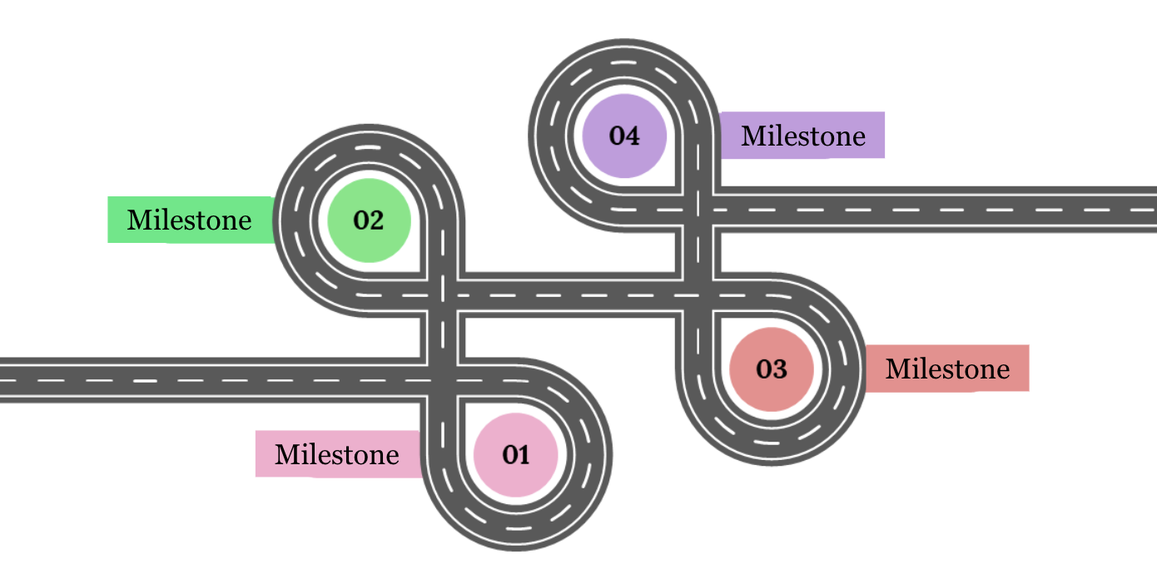

Milestone 1:
Milestone 2:
Milestone 3:
Milestone 4:
B. Make a mentorship plan
Logistics: How will you communicate with your mentor(s)? How often will you meet to discuss research progress and challenges?

Roles: What will you contribute to the project or broader research objectives? Be as specific as possible. How will your mentor guide you?

Mentorship style: How can your mentor(s) best help you succeed? This could include anything from group practices to individualized guidance.

Looking forward: You might find more hands-on mentorship to be useful at first. As you progress, you may gain increased independence in your research.
Consider the following:
- How might the mentoring relationship evolve over time?
- How could your mentor continue to support your longer-term research goals?

