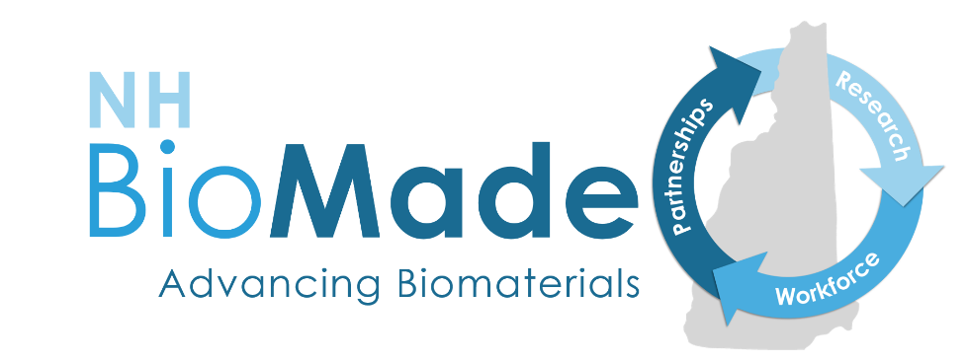
NH BioMade Educational Grant Opportunity:
Attracting, Training, and Retaining a Skilled Workforce
2019 REQUEST FOR PROPOSALS:
WITHIN GRADE-BAND PROJECTS: https://unh.infoready4.com/#competitionDetail/1783127
ACROSS GRADE-BAND PROJECTS: https://unh.infoready4.com/#competitionDetail/1788808

Questions? Email nh.epscor@unh.edu

Summary
This opportunity is for NH education and/or industry professionals to develop and implement curriculum or training enhancements that will address skills gaps to better prepare students to enter a career or academic pathway in biomaterials or bio-related advanced manufacturing. Eligible projects will support secondary schools, career and technical education centers, community colleges, four-year colleges and universities, and informal science programs. We expect to support up to seven within grade-band projects (up to $5,000) and four across grade-band projects (up to $10,000). Grade bands are defined as grades 6-8, grades 9-12, undergraduate, and graduate. Projects must be completed in one year unless a longer time period is approved. There is a possibility of year 2 funding for exceptional proposals. At the end of the project, we expect evidence of the creation and implementation of educational enhancement(s) to address the skills gap listed in this RFP.
The application deadline is August 31, 2019.

Purpose of this Grant Program
The purpose of this funding opportunity is to diversify the STEM workforce and to develop educational enhancements to better prepare New Hampshire students to enter a career or academic pathway in biomaterials and bio-related advanced manufacturing. Eligible projects will support NH secondary schools, career and technical education centers, community colleges, four-year colleges and universities, and informal science programs in developing and implementing curriculum and training enhancements that lead to inclusion of underrepresented groups in STEM industries and address the skills gaps summarized below and included in the appendix.

Background
NH BioMade, a statewide initiative funded by the National Science Foundation, supports the rapidly growing New Hampshire biomaterials industry. Advances in biological research hold potential to save patient lives and improve overall quality of life. Biomaterials, such as those used in implants and tissue engineering, have stringent and potentially conflicting specifications (weight, strength, porosity, electrical conductivity, and complex geometries). NH BioMade will advance the design and manufacture of biomaterials and develop the knowledge to predict and control their composition, structure, properties, and function. For more information visit www.nhepscor.org/nh-biomade.
NH BioMade’s workforce development program aims to attract, train, and retain a more diverse biomaterials and bio-related advanced manufacturing workforce by supporting students’ development of the knowledge and skills needed to contribute to this industry cluster. Skills gaps have been identified within core areas related to BioMade research: computational modeling, advanced manufacturing, biomaterials and bioprocessing as well as foundational work skills.

Skills gaps
Successful projects will address one or more of the skills gaps listed below. Projects supporting middle and high school students can address more foundational and basic skills gaps than post-secondary projects. Please note: This RFP does not prescribe which gaps are relevant to which grade level of students. It is up to the applicant to make the case for how the gap they choose will be addressed across or within their grade bands.

Foundational work skills
- Career readiness
- Communication
- Critical/creative thinking
- Entrepreneurial thinking
- Problem solving
- Professional behavior
- Project management
- Team leadership

Computational thinking/modeling
- Logic models
- Simple programming
- Advanced programming
- Computational molecular bioengineering
- Compute Unified Device Architecture (CUDA) programming

Advanced manufacturing
- Hands on experiences with:
  - Basic engineering processes/skills
  - Basic manufacturing processes/skills
  - Advanced manufacturing processes/skills
  - Biomanufacturing processes/skills
- Statistics
- 3D printing
- Mechanics in manufacturing
- Biomanufacturing control systems

Biomaterials
- Lab experience
- Mechanical behavior of biomaterials
- Advanced materials characterization
- Tissue engineering

Deliverables and outcomes
This RFP is intended to impact the educational setting. Examples of types of deliverables this opportunity could fund are below; however, this is not an exhaustive list. Deliverables must address a skills gap from the list in the previous section.
- Elective courses or course modules
- New industry-school partnerships or expansion of old partnerships
- Curricula to improve career awareness through experiential learning
- Evidence of increased direct interaction between learners and industry
- Curricular and extra-curricular activities focused on career pathways

Eligibility
Education and/or industry professionals within NH who seek to develop educational enhancements related to the skills gaps identified above are eligible to apply. If you have questions about eligibility, please contact: nh.epscor@unh.edu.

Available Funding
Projects focused on a single grade band (e.g., grades 6-8, grades 9-12, undergraduate, graduate) may request up to $5,000. Projects that span grade bands (e.g., collaborations to bridge transitions between educational levels) may request up to $10,000. Projects must be completed in one year unless a longer time period is approved. There is a possibility of year 2 funding for exceptional proposals.
We expect to support up to seven single grade-band projects and up to four across-grade-band projects in 2019. The number and size of awards will vary according to the scope of the projects.

Required information
You will need an InfoReady Account. Instructions are on the last page of this document.
Format for all documents: 1-inch margins, 12-point font, single spaced.
Please note: Proposals that do not include all required information will not be reviewed.

Cover Page
- Applicant’s name, position or title, institution or school, email address, telephone, mail address.
- Anticipated start date and completion date (one year unless specifically approved for more).
- Collaborator(s) name, position or title, institution or school

Detailed Project information and Description
- Project title
- Project description (up to 6 pages). Describe your concept for this curriculum and training enhancement project by addressing the following questions:
  - What are the project objectives, deliverables and associated tasks?
  - Which skills gap(s) does the project address?
  - How will the deliverables be made inclusive of all learners especially those students underrepresented in STEM disciplines within your student population. (See here)
  - How will the project be evaluated and what are the qualitative and/or quantitative metrics/indicators you will collect and analyze?
  - Roles and responsibilities: Include a brief statement (less than a half page) for each person describing their role on the project and their qualifications for filling that role.
  - How will project collaborators interact, share information, manage students, and make decisions throughout the project?
- Project timeline: please provide a timeline with milestones

Budget
- Fill out the budget template provided.

CV/Resume
- Include a CV or resume (2-page limit) for applicant and all collaborators combined into a single PDF

Budget
Funds may be requested for materials or supplies, travel, salaries or wages, fringe benefits, institutional overhead or other expenses. Use the budget template and provide specifics for each item. Budgets must comply with federal guidelines for allowable costs expensed to grants. For example: meals, refreshments, gift cards, incentives, awards and clothing are not allowable costs. If you have questions about allowable costs, please contact: nh.epscor@unh.edu.

Application Process
- Create InfoReady account
- Upload application to the UNH InfoReady Portal
- Application deadline: July 15, 2019
- All applicants will be notified of the outcome of the review process by September 1, 2019
- Earliest Start Date: September 1, 2019

Review Process
A panel of reviewers including representatives from secondary education, colleges and universities, and industry will evaluate applications. Successful proposals will address the NH BioMade skills gaps and will result in measurable outcomes. Proposals should be designed to be inclusive of all learners, especially those students underrepresented in STEM disciplines.
The following groups are seen as underrepresented in STEM fields:
- Women
- Persons with disabilities
- Three racial and ethnic groups—
  - Blacks
  - Hispanics
  - American Indians, Alaska Natives, or Pacific Islanders
- Veterans
- LGBQTA
- Low socio-economic status (proportion of students receiving free and reduced lunch, financial aid metrics)
- First generation college attendee

The following criteria will be used in the review of proposals:
- To what extent does the proposed project better prepare New Hampshire students to enter a career or academic pathway in biomaterials and/or advanced manufacturing?
- Does the project effectively address one or more skills gaps identified in the request for proposals?
- To what extent is the plan for carrying out the proposed activities well-reasoned, well-organized, and based on a sound rationale?
- Is the project inclusive of all learners in the proposed grade band(s)?
- How effective is the evaluation strategy?
- How well qualified is the individual, team, or organization to conduct the proposed activities?
- Is the project likely to be completed in the time allowed?
- To what extent does the proposed budget adequately support the proposed activities?

Award conditions
Projects selected for funding will be required to:
- Sign a memorandum of understanding for terms and conditions
- Submit quarterly detailed invoices aligned with the project budget
  - Submit reports (a template will be provided)
  - Quarterly progress reports
- Final project report within 30 days of completion
- Participate in NH BioMade evaluation and assessment activities: a single online survey or interview
- Present the results of the project at a conference or symposium as a poster or oral presentation. NH BioMade staff is available to assist with this.

How to Request InfoReady Account
To request an account, please send an email to Lynnette Hentges at lynnette.hentges@unh.edu with the following information:
- Name
- Address
- Phone Number
- Email Address
- Competition that you’re applying to

When an account has been created for you, you will receive an email from the InfoReadyReview system. This may take up to 3 days.
Follow the directions to create a password and complete your account set-up.

NH BioMade is supported by an EPSCoR Research Infrastructure Improvement award (#1757371) from the National Science Foundation. The program is administered by the NH EPSCoR state office at the University of New Hampshire. For more information, visit www.nhepscor.org

